|  |  |
| --- | --- |
| Power BI Case Study Document | |
|  |  | | |
| **Writer:** | I&D Microsoft | | **Initials entity:** |
| **Date creation:** 06/06/2018 | |  | **Last upgrade:** 08/06/2018 |

Power BI Case Study Document

Accuright

|  |  |  |  |  |
| --- | --- | --- | --- | --- |
| Version | Author | Comment | Reviewed By | Date |
| V 1.0 | I&D Microsoft | Initial draft | Moupiya Das |  |

**Table of Contents**

**Introduction****……………………………………….……………………………………………………….…….………………..……………..3**

1. **Querying Data****……………………………………………..………………………………….………………….………………………………4**
2. **Data Modelling****……………………………………………………………………………………………………………………………………4**
3. **Data Optimization****………………………………………………………………….…………………….………………………………….…4**
4. **Report 1 – Catastrophic Data****……………..………………….………………….………………..………………………………………5**
5. **Report 2- Property Insured****.…………………………………………………………………………….………………………………….7**
6. **Publishing and Sharing Reports****……………………………………………………………………….……………………………….…9**

# Power BI – Accuright Case Study

**Introduction:**

In this Case Study you will be addressing the Issue of '**Accuright’**. ACCURIGHT is an Insurance industry-specific enterprise, providing orchestration environment for big data, machine learning, artificial intelligence and advanced analytics. By combining data science and domain expertise, Accuright helps us for a forward-looking and digitally enabled insurance venture.

The solution aims to offer Accuright, valuable insights of how their business is doing, what is perfectly working and what should be improved, by addressing different areas of the business like Towing Reduction, Fraud Detection and Anomaly Detection. You are provided with Accuright data attached within, for creating reports on Power BI.

For performing interactive Visualization reporting out of it, first you need to prepare a data model.

**Prerequisites:**-

🡪 Latest **Power BI Desktop** should be installed in the system.

Data Sources:



Here we create 2 separate reports using the files provided as data sources. In the first report we import Property_for_Dashboards.csv and MASTER Sheet from Copy of Property_for_Dashboards.xlsx

# Querying Data

**Catastrophic Data**  
Property_for_Dashboards.csv and MASTER Sheet from Copy of Property_for_Dashboards.xlsx

**Insured Property**  
Import CRUIS Pricing.csv, CRUIS_Revamped.csv and CRUISRiskScoreData.csv

# Data Modelling Catastrophic Data

Create relationship between Master and Property for Dashboard table. (Make sure the cardinality and cross filtering direction is chosen correctly.)

# Property Insured

Create Relationship between all tables using business name or Client list as the key.

# Data Optimization

* 1. Rename Sheets and table as per your convenience.
  2. Hide/Delete tables/columns if not needed.

# Report 1- Catastrophic Data

* 1. Give ‘Catastrophic Data’ as the title for the Report.
  2. Use a visual to filter the page on Risk_rating. Add images to the filter values and keep one value selected **at all times**. Snapshot for reference has been provided below.

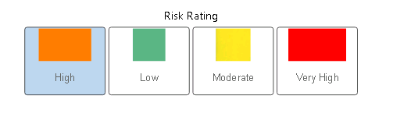

* 1. Sort the above created visual to show values in order of Low, Moderate, High and Very   
     High.
  2. Use Map visual to mark locations using latitude and longitude. Keep separate color based on Risk Rating. Map should look like this:

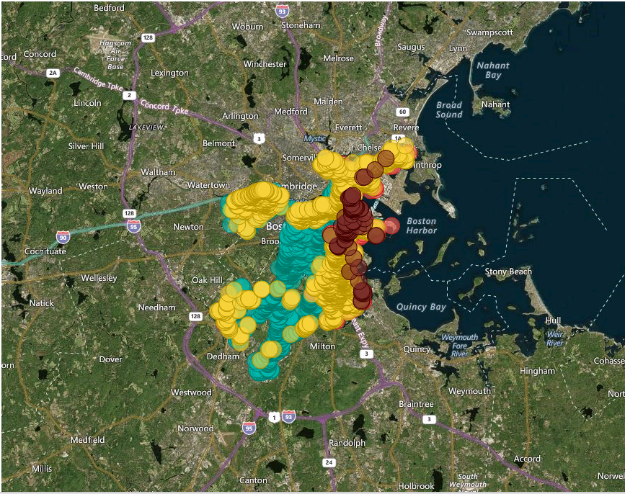

* 1. Create a slider like visual to filter values using Risk Score. Make the Range 0 to 10 for it.
  2. Display Risk Score values for Cumulative Risk, Floodplain Risk, Property Extrinsic, Property Intrinsic, NBH Futuristic, Loss History, Claims Risk, and Event Risk for Property ID.   
       
     Set their background color based on the following rules:

If cumulative Risk >0 and <2.5 set color 01B8AA

Else If cumulative Risk >2.5 and <5 set color F2C80F

Else If cumulative Risk >5 and <7.5 set color FD625E

Else cumulative Risk >7.5 and <10 set color 7F312F  
  
for all the other Risk Score values use the following Rule:

If Risk >0 and <1 then color is 01B8AA

Else If Risk >1 and <2 then color is F2C80F

Else If Risk >2 and <3 then color is FD625E

Else If Risk >3 and <4 then color is 7F312F

After formatting, the visual should look like this:

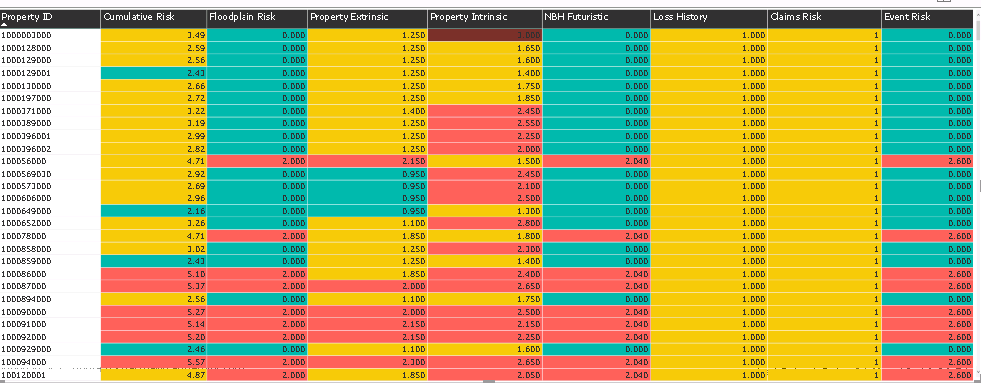

* 1. Create a visual to show count of PID based on Risk Rating. (Try using custom visual to enhance the aesthetics.) Name the visual as ‘Risk View’
  2. In the Risk View visual, show values just for High and Low Risks.

# Report 2- Property Insured

* 1. Give ‘Restaurant Property Insured’ as the title for the Report.
  2. Create a visual to show scores for Food Safety, Community Sentiment, Fire Safety, Financial Health, Geographic Risk, and Final Score by Month Year. (Use CRUIS_Revamped table for Data) Set Separate colors for all score values. Name the visual as ‘Risk Trend Graph’.
  3. For Risk Trend Graph Visual show month year as mm-yy for the last 12 month only. (For example if the current month is June, the month year should start from Jun-17 and show data for till Jun-18)
  4. Sort Month Year as per the months of the year respectively.

Refer the given image for reference:

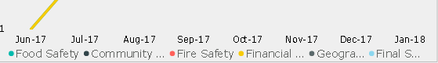

* 1. Create a visual to filter the page on business name from dropdown. Name the visual as ‘Client List’.
  2. Replicate the given below visualization:

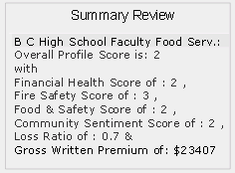

The First Row of the visualization shows the current filter applied on Client List.

(Hint: Use Cruis_Revamped as source. Aggregation is Average for all values except Loss Ratio. Use maximum as aggregation for Loss Ratio. Make Use of DAX.)

* 1. Create visual(s) to show difference in segment change for current and previous year for a particular Client i.e. Business Name. Refer the image provided for reference.

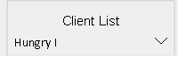 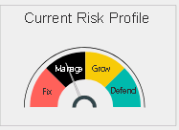 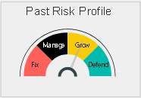  
  
(Note: It is not necessary to replicate the same visual. Feel Free to come up with a better one to depict the same data under the same conditions. )   
(Hint: Use CRUIS_Revamped table)

* 1. Create a visual which displays results based on the following conditions:

|  |  |  |  |
| --- | --- | --- | --- |
| S.no | Segment in 2016 | Segment in 2017 | Results |
| 1. | Manage | Defend | Discount Premium by 5 % |
| 2. | Manage | Grow | Discount Premium by 10 % |
| 3. | Manage | Fix | Load Premium by 5 % |
| 4. | Grow | Defend | Load Premium by 5 % |
| 5. | Grow | Manage | Load Premium by 10 % |
| 6. | Grow | Fix | Load Premium by 15 % |
| 7. | Defend | Grow | Discount Premium by 5 % |
| 8. | Defend | Manage | Load Premium by 5 % |
| 9. | Defend | Fix | Load Premium by 10 % |
| 10. | Fix | Manage | Discount Premium by 5 % |
| 11. | Fix | Defend | Discount Premium by 10 % |
| 12. | Fix | Grow | Discount Premium by 15 % |
| 13. | Else | No change in Premium | |

# Publishing and Sharing Reports

* 1. Now it’s time to publish your reports. Create a new app workspace named ‘*PowerBI_Test’* using Power BI Service.
  2. Add your friends to workspace so that you can share your reports with them.
  3. Publish your reports to Workspace.
  4. In ‘*PowerBI_Test’* workspace, create a new dashboard.
  5. Create a well-designed dashboard to tell insights of your data.
  6. Pin Visualizations of your choice from your report to have quick insights into the report.